EUR-Greece-Archaic-5th Cent BCE

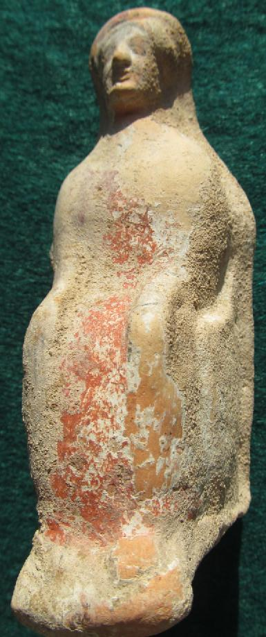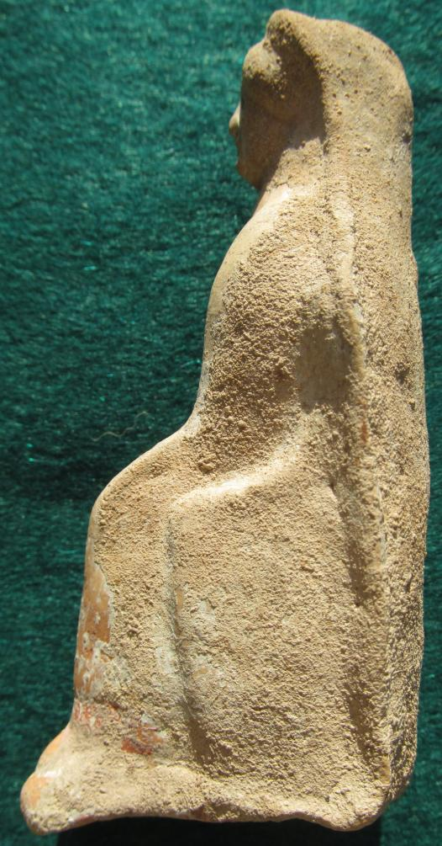 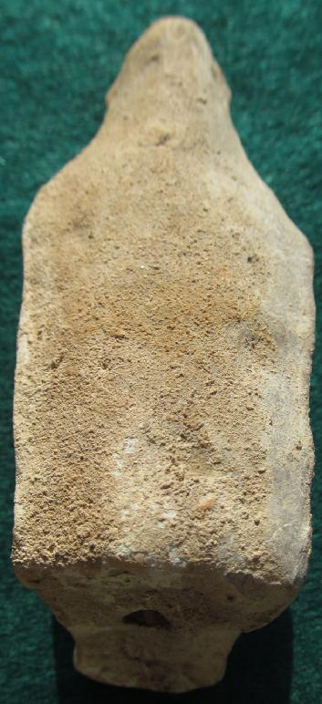

Greek Attic Terracotta, Seated Woman, with red Himation, Chiton, Late Archaic, early 5th cent. BCE